**Implementation of Root Locus using MATLAB**

**Lab#10**

Submitted by**:**

**Maaz Habib**

Registration Number**:**

**20PWCSE1952**

Section:

**C**

Submitted To**:**

**Dr. Muniba Ashfaq**

January 31, 2024

**Department of Computer System Engineering**

**University of Engineering and Technology Peshawar**

**Objectives:**

* Finding the root locus of a system using MATLAB‟s built-in commands
* Understanding the use of “rlocus” command in MATLAB

**Problem Statements:**

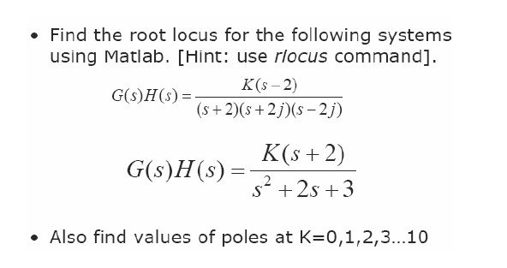

# G(s)H(s) = K(s-2)/(s+2)(s+2j)(s-2j)

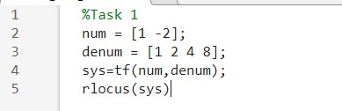

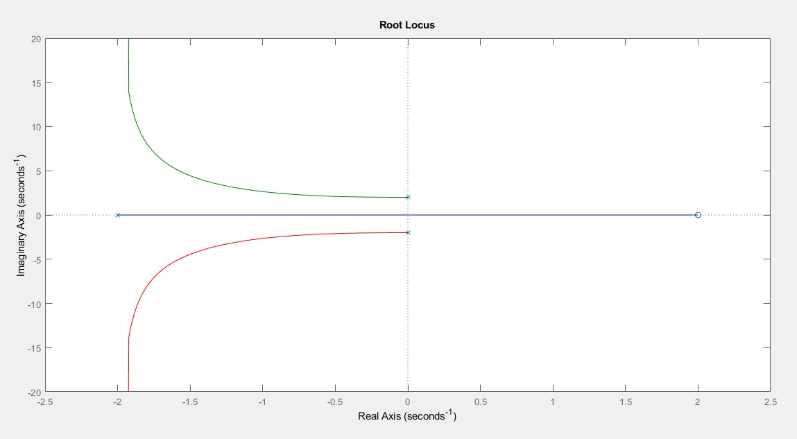

# For values of K

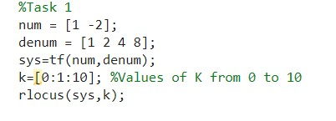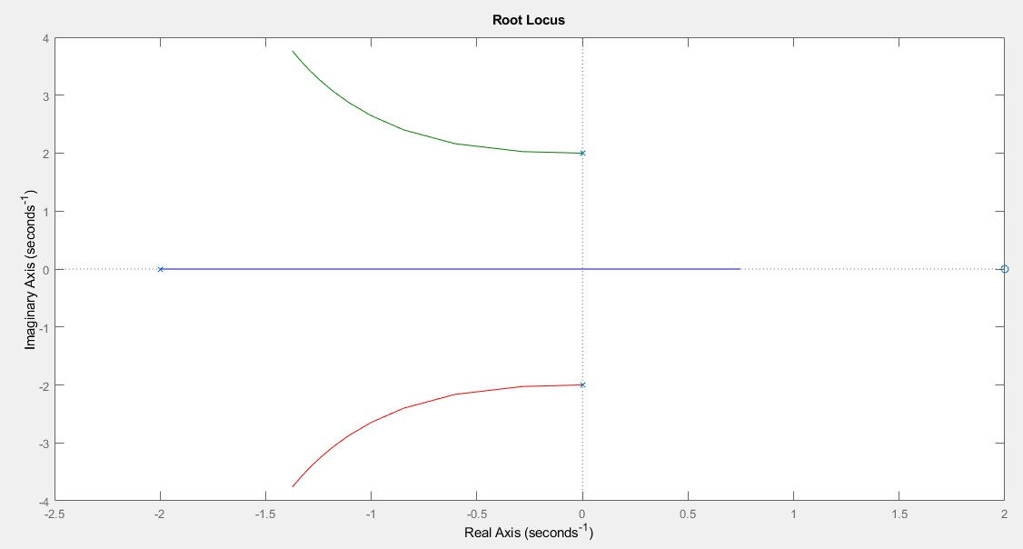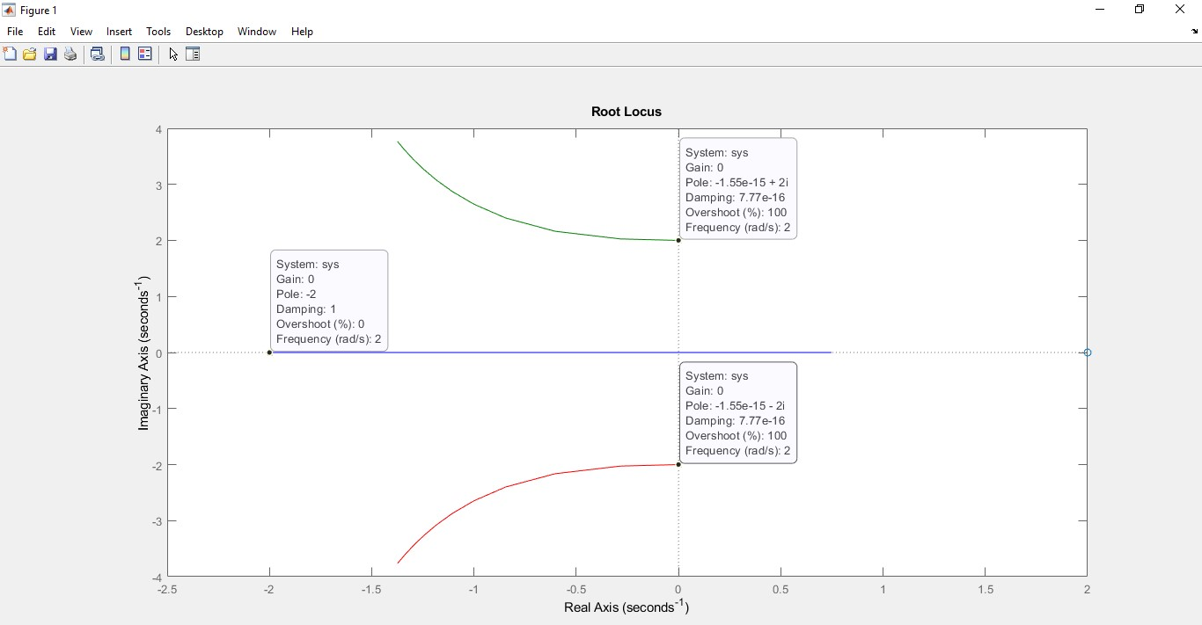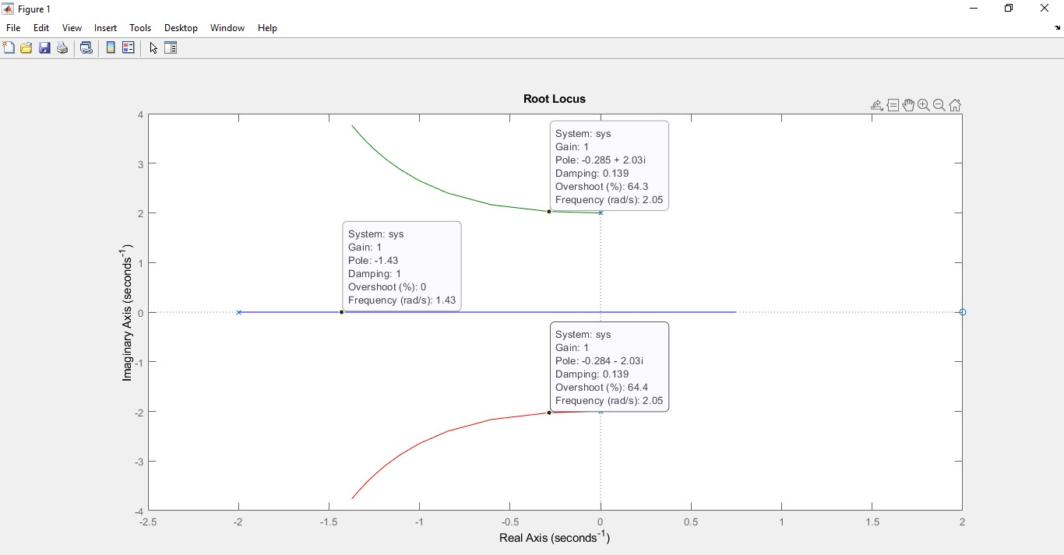

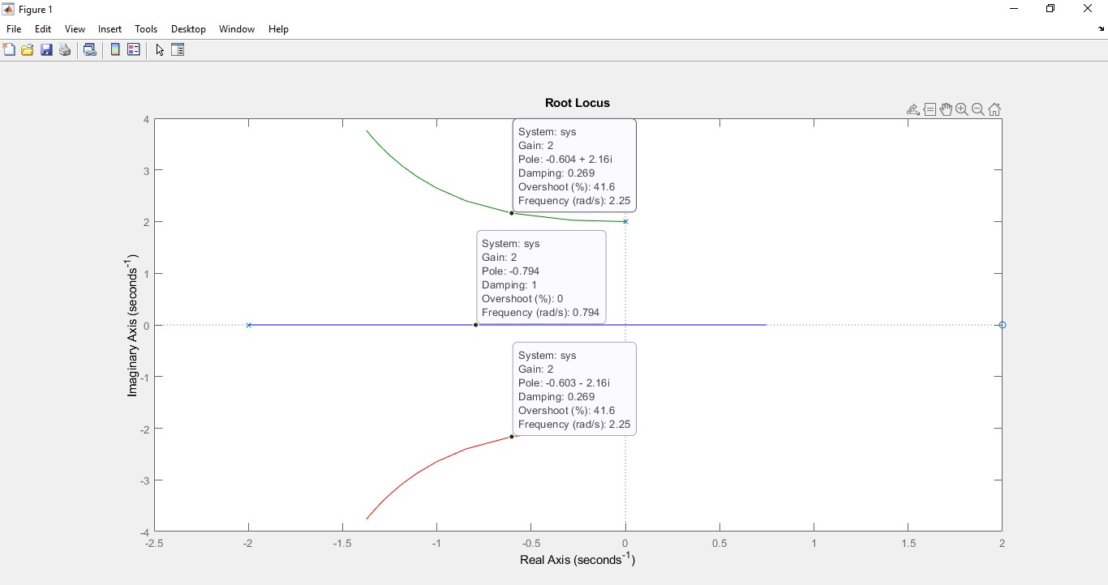

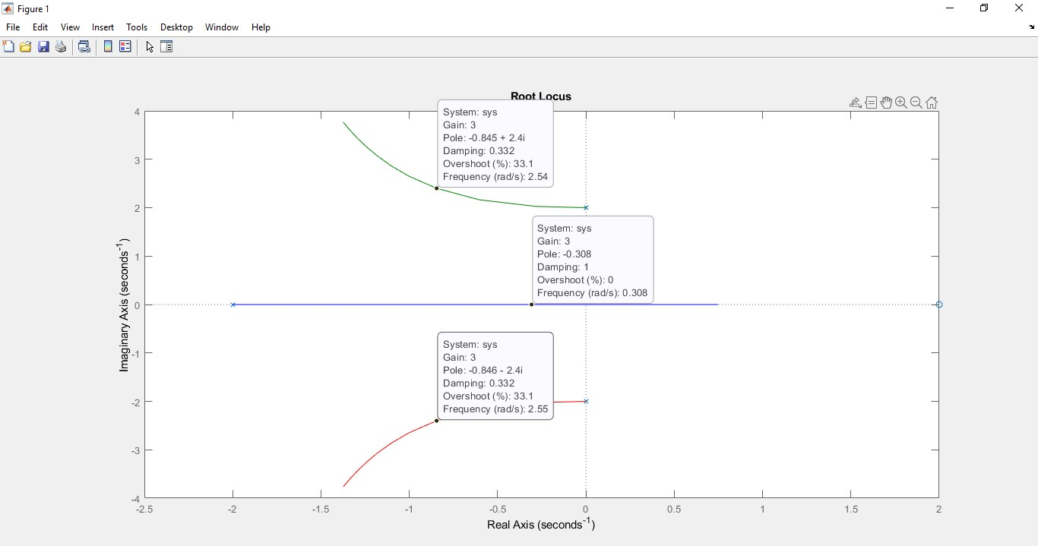

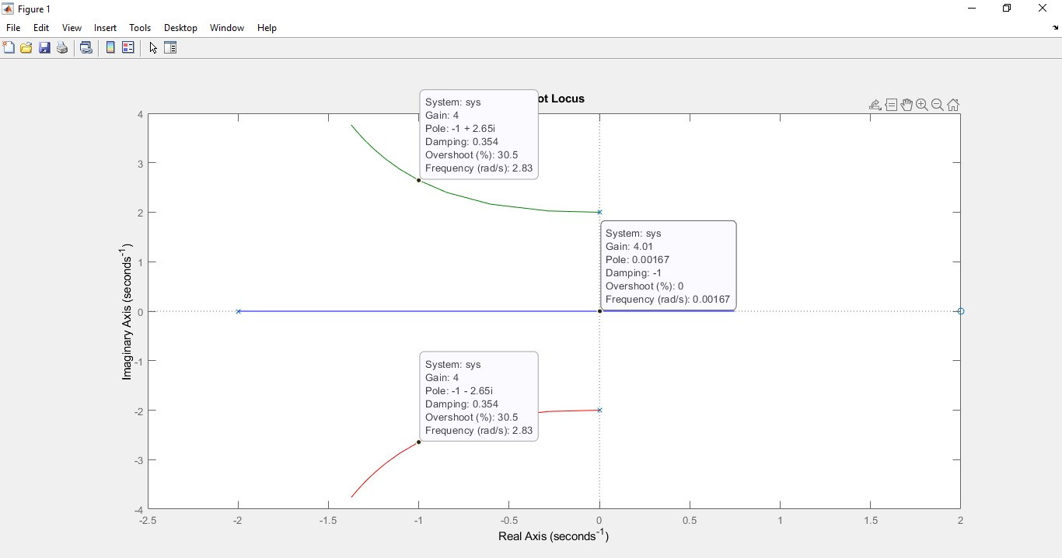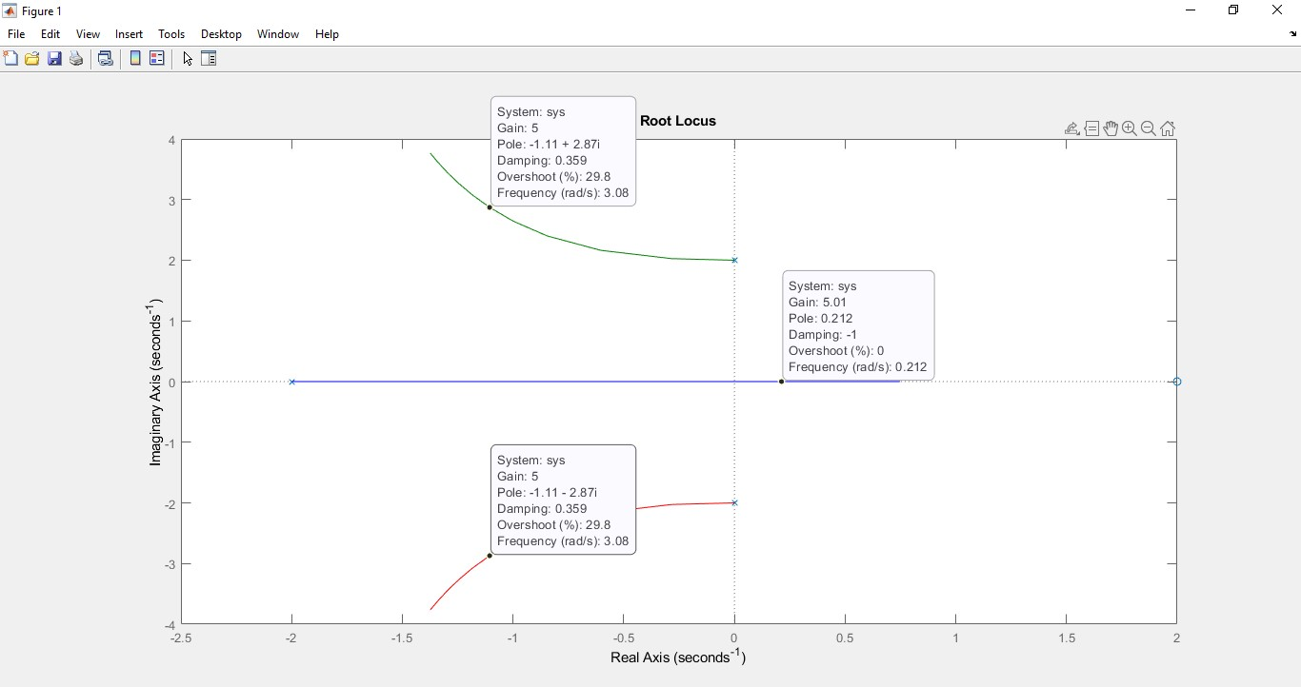

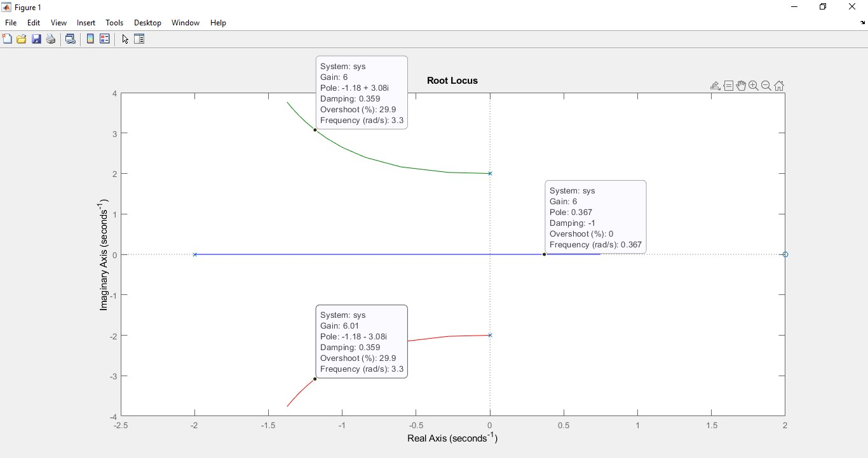

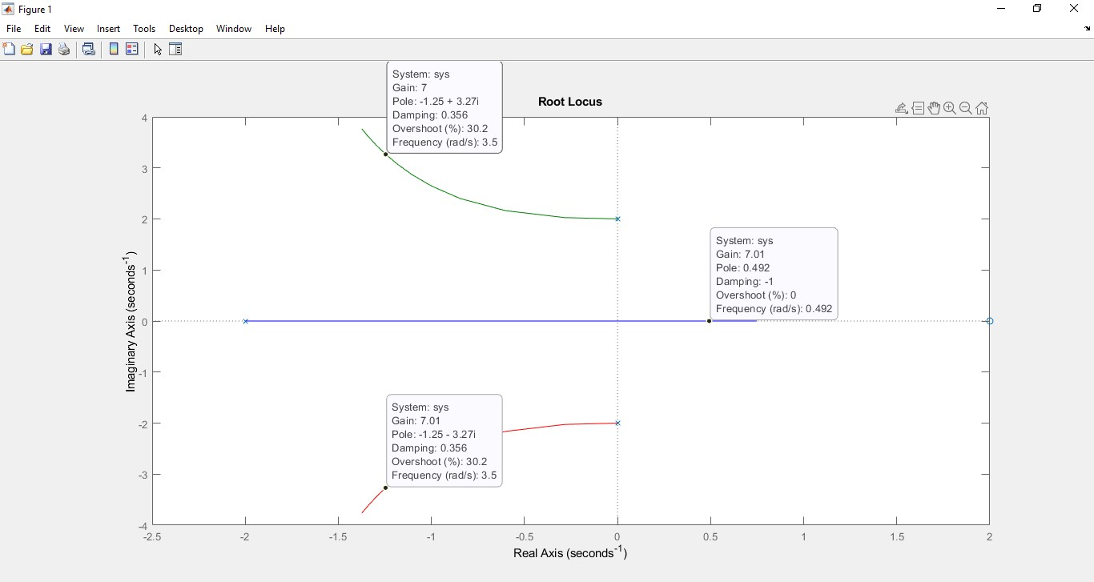

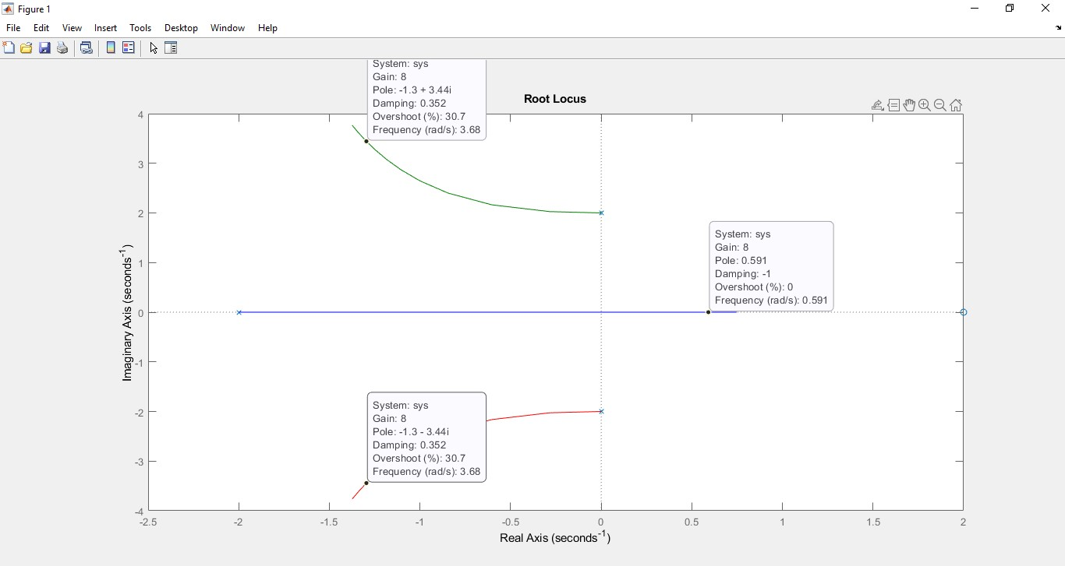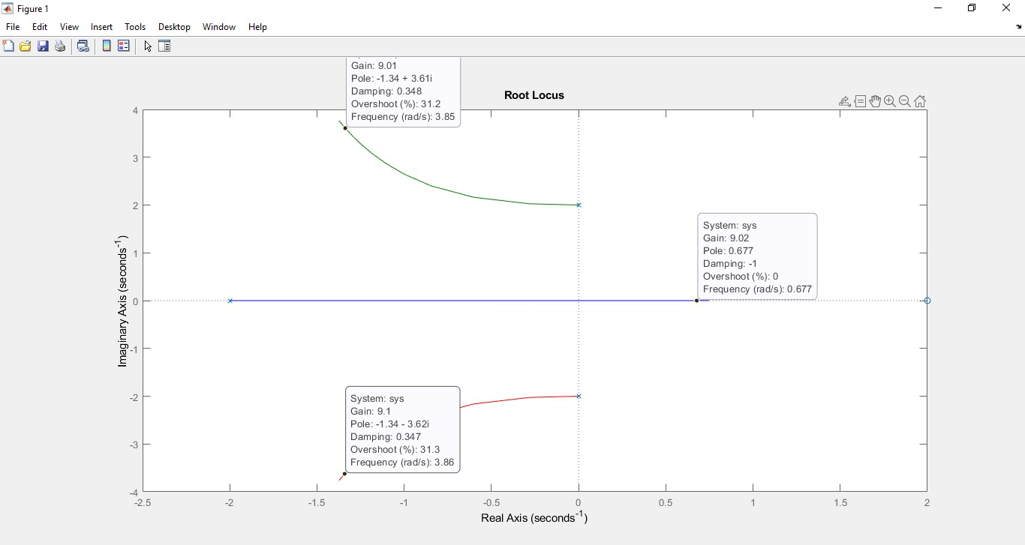

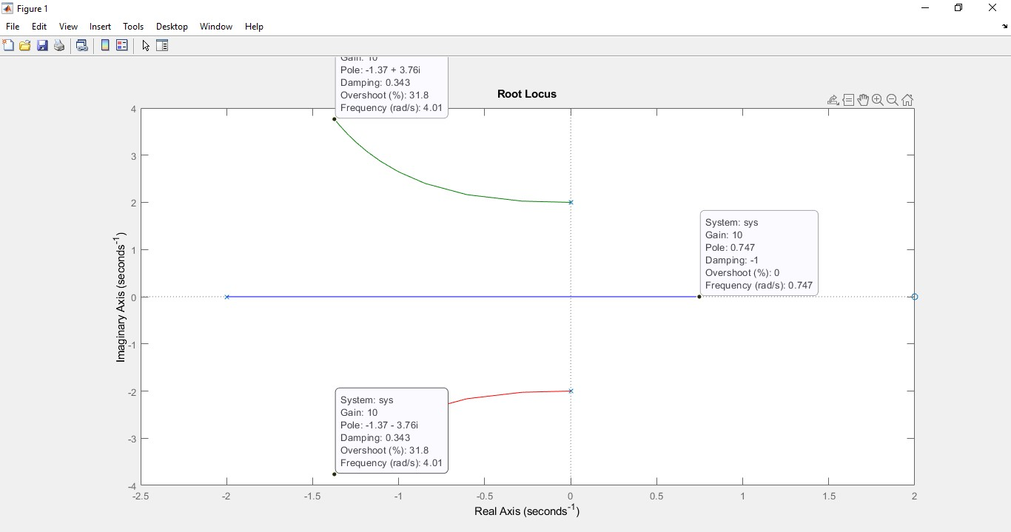

|  |  |
| --- | --- |
| **Values of K** | **Value of Poles** |
| 0 | -2, 6.11e-16+2i, 6.11e-16-2i |
| 1 | -1.43, -0.284+2.03i, -0.284-2.03i |
| 2 | -0.793, -0.603+2.16i, -0.603-2.16i |
| 3 | -0.309, -0.846+2.4i, -0.846-2.4i |
| 4 | 8.88e-016, -1+2.65i, -1-2.65i |
| 5 | 0.211, -1.11+2.87i, -1.11-2.87i |
| 6 | 0.368, -1.18+3.08i, -1.18-3.08i |
| 7 | 0.491, -1.25+3.27i, -1.25-3.27i |
| 8 | 0.591, -1.3+3.44i, -1.3-3.44i |
| 9 | 0.675, -1.34+3.61i, -1.34+3.61i |
| 10 | 0.747, -1.37+3.76i, -1.37-3.76i |

**Analysis**

Loop gain or K start from 0 and approaches to 3.99 for stable system. As the values goes beyond 3.99 or 4 so the system become unstable. K is stable for 0 to 3.99 and unstable for 4 to 10.

# G(s)H(s) = K(s+2)/s^2+2s+3

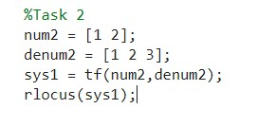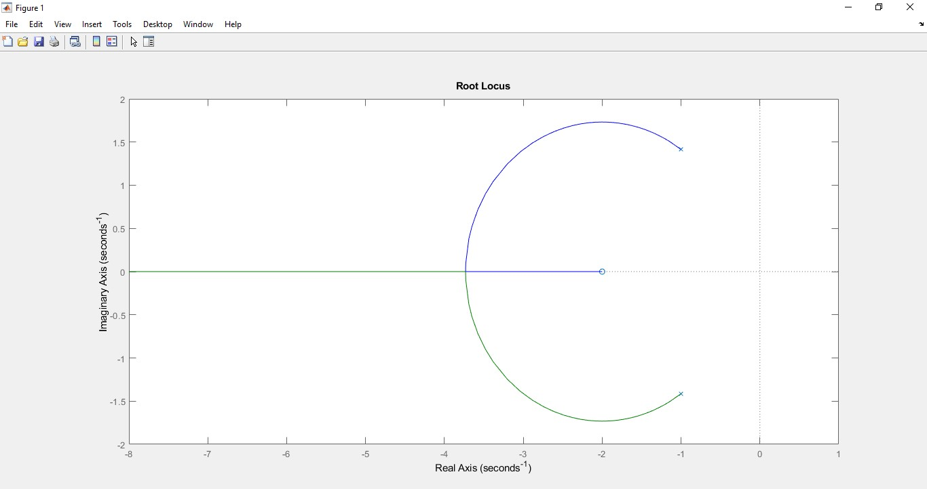

# For values of K

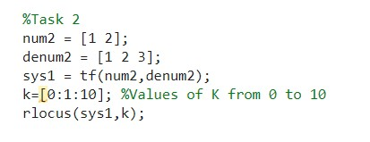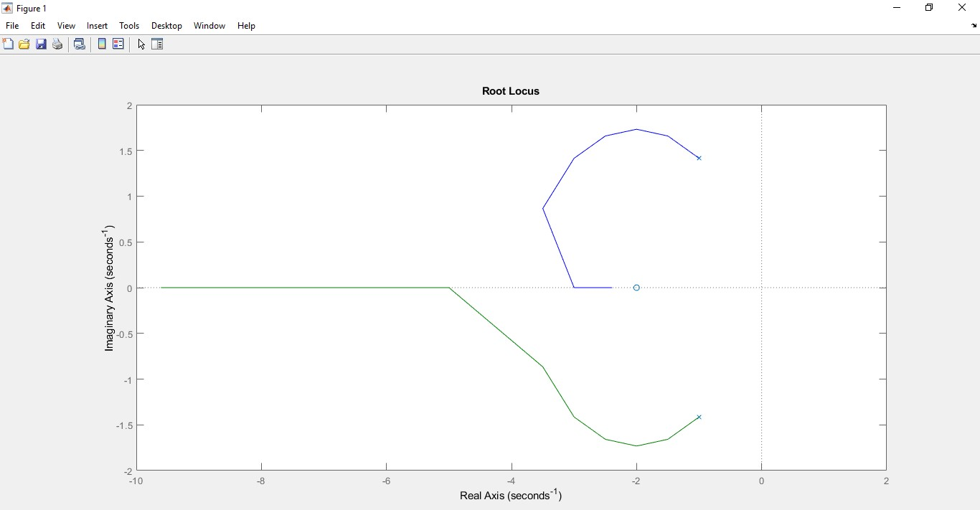

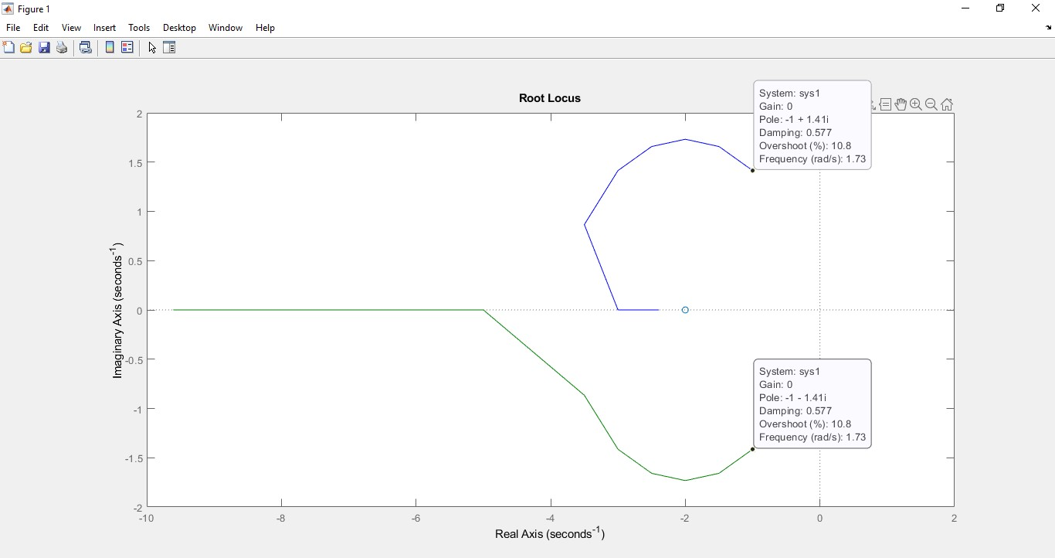

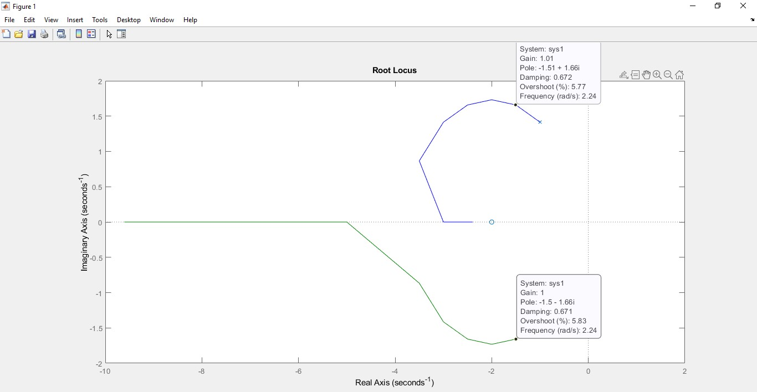

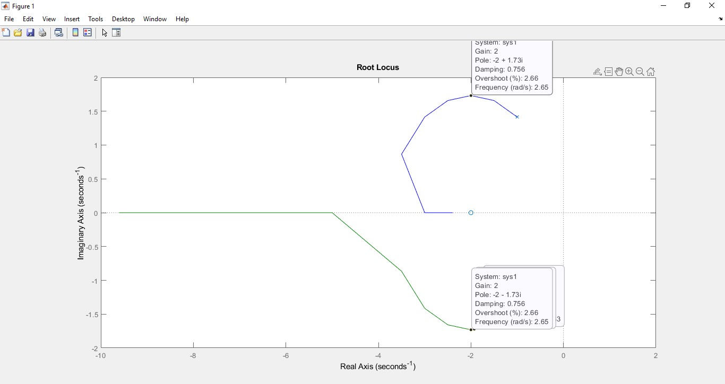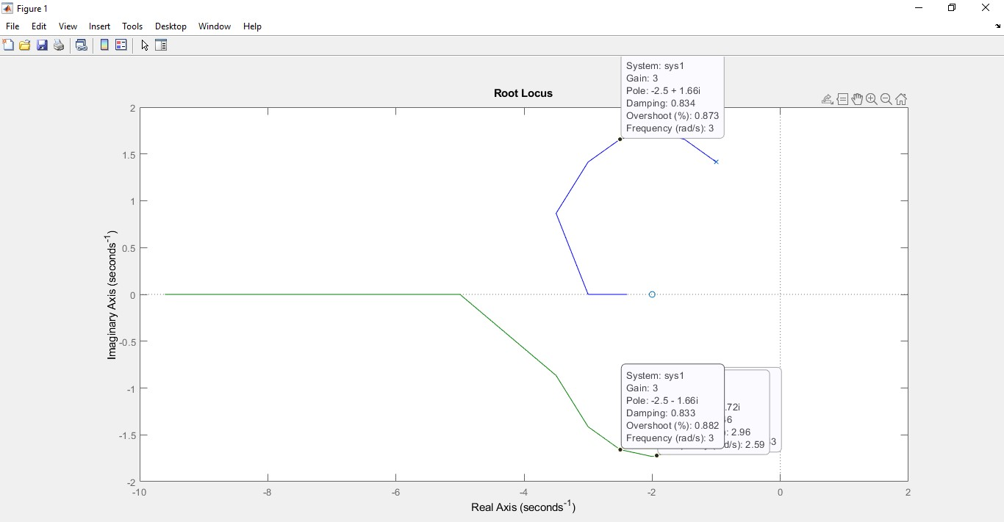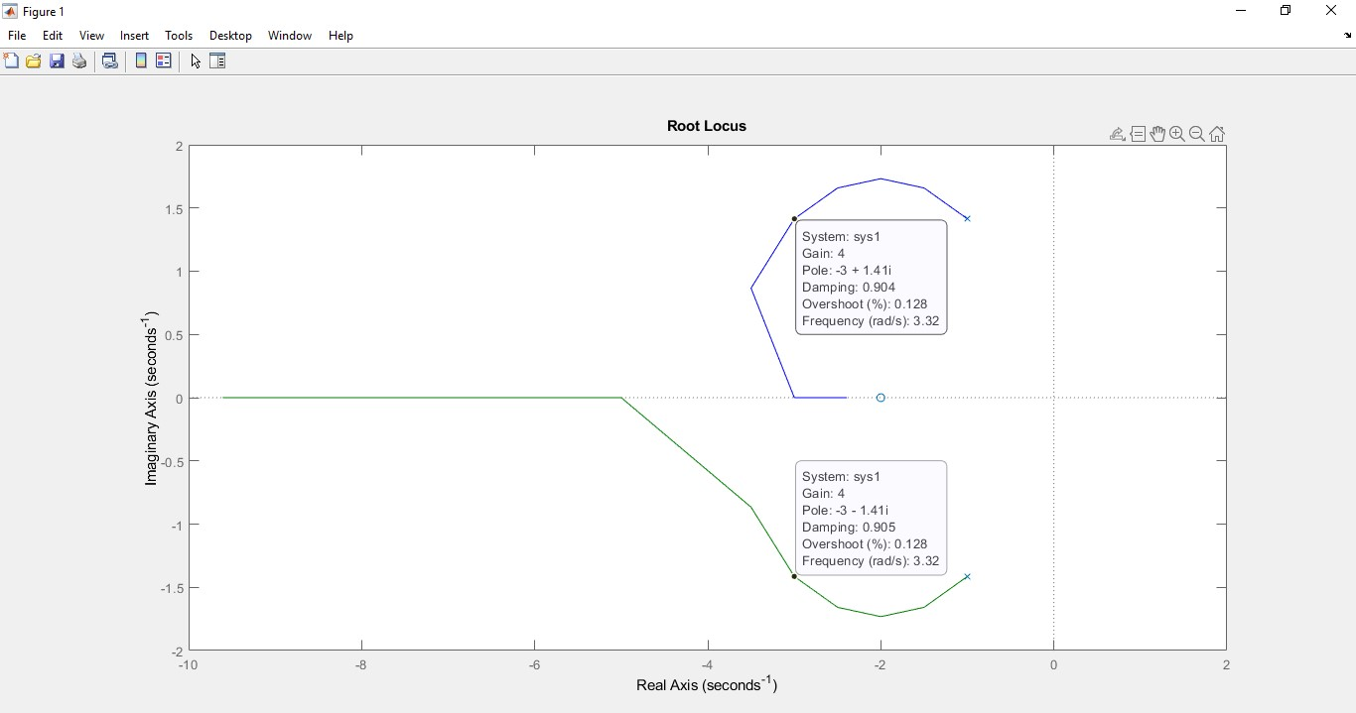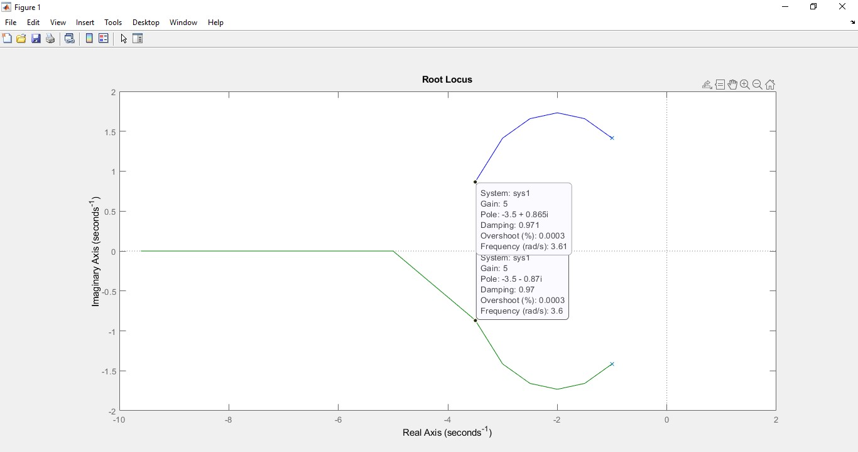

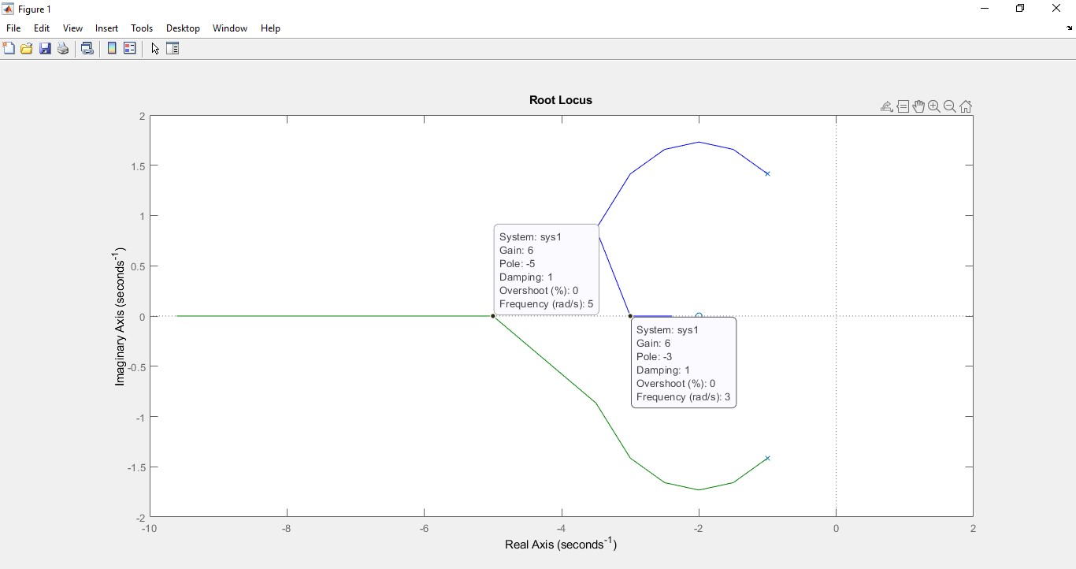

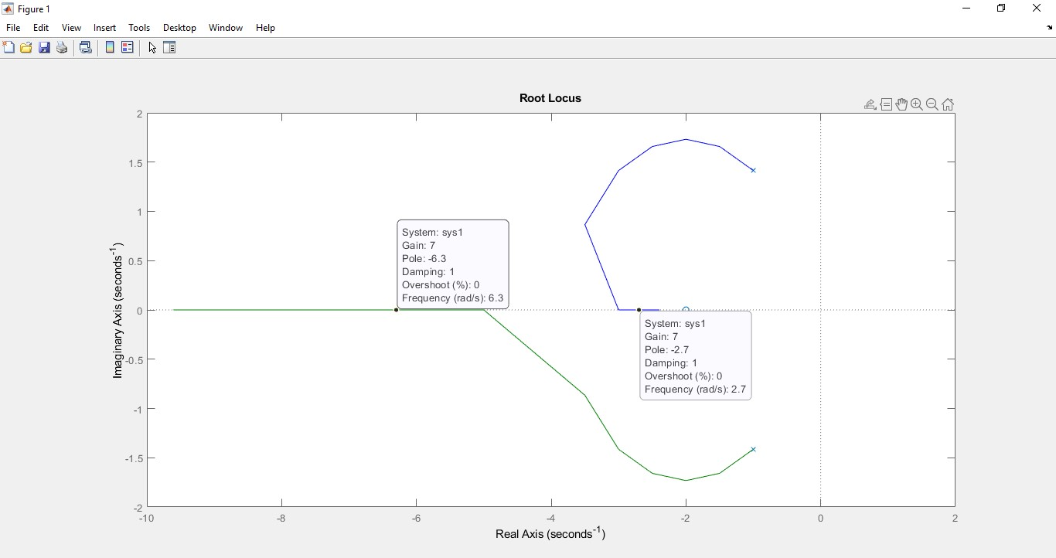

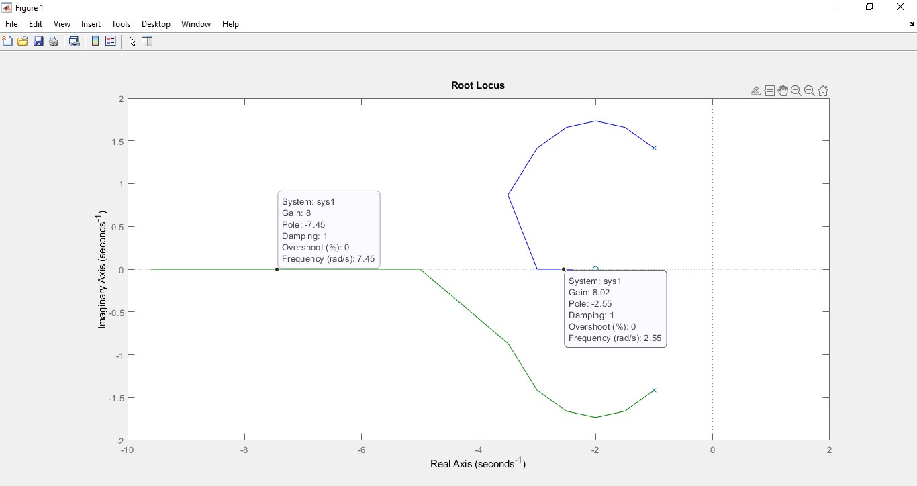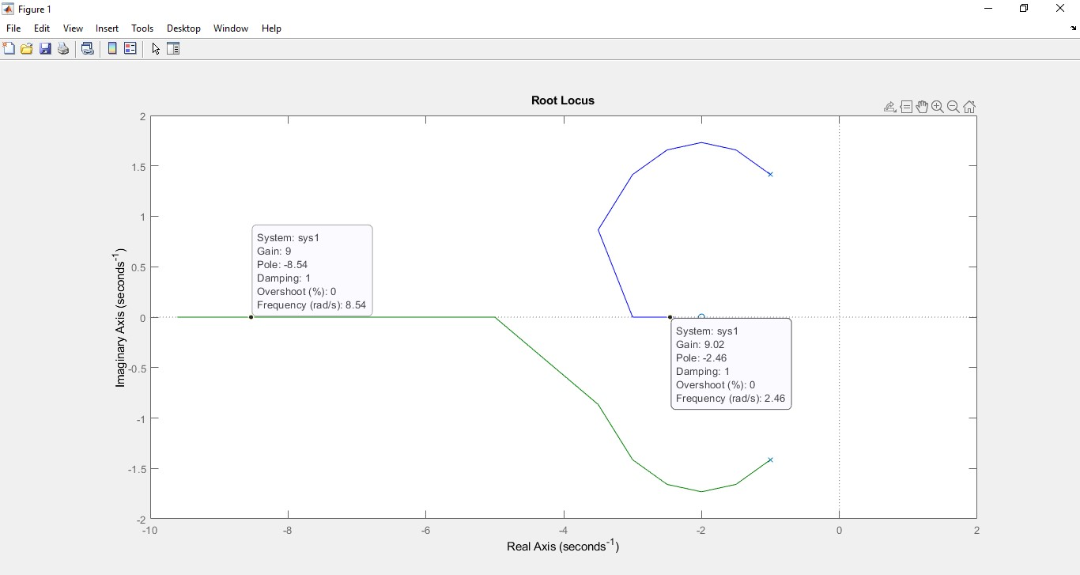

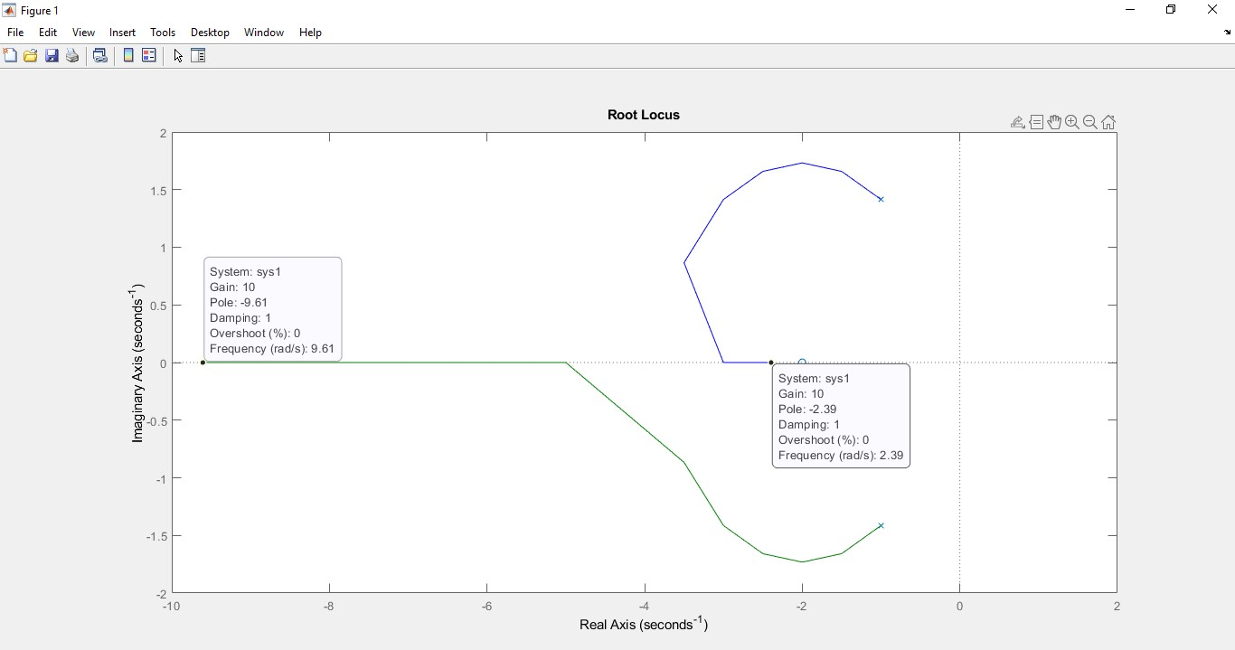

|  |  |
| --- | --- |
| **Values of K** | **Value of Poles** |
| 0 | -1-1.41i, -1+1.41i |
| 1 | -1.5-1.66i, -1.5+1.66i |
| 2 | -2-1.73i, -2+1.73i |
| 3 | -2.5-1.66i, -2.5+1.66i |
| 4 | -3-1.41i, -3+1.41i |
| 5 | -3.5-0.87i, -3.5+0.87i |
| 6 | -5, -3 |
| 7 | -6.3, -2.7 |
| 8 | -7.45, -2.55 |
| 9 | -8.54, -2.46 |
| 10 | -9.61, -2.39 |

**Analysis:**

The value of K or loop gain starts from 0 and it goes on the 10, the value of poles at each value of K is negative which shows that the system is unstable between 0 and 10 values of K or loop gain.

**Conclusion:**

Rlocus() is used to check the stability of a system. It's very hard to determine from the differential equation or the transfer function of a system whether the system is stable or not.

MATLAB helps in finding many other properties or characteristics of a system.